

THE COPPERBELT UNIVERSITY  
SCHOOL OF INFORMATION COMMUNICATION TECHNOLOGY

Smart Bin: AI-Driven Waste Sorting  
Project Report

**Done By**

Name: Bulaya Mwanaute

SIN: 20150307

Programme: Computer Engineering

Supervisor: Prof. Mbale

# Abstract

The project presents the design and implementation of a smart, AI-powered waste sorting bin aimed at improving waste management practices through automation. Improper waste segregation at the disposal stage contributes significantly to the growing challenges of landfill overflow, poor recycling efficiency, and environmental pollution. This project leverages image classification and servo-controlled hardware mechanisms to detect and sort waste items like plastic, metal, and glass into appropriate compartments. Additionally, it incorporates an incentive mechanism using a coin dispenser to encourage proper recycling. The system consists of a microcontroller, a camera module, ultrasonic sensor, and servo motors that control various mechanical components. The innovation lies in applying embedded AI on a small scale, allowing deployment in homes, schools, or public spaces without the need for massive infrastructure. The project combines concepts from computer engineering, machine learning, and sustainable design, offering a scalable and educational solution to one of today’s most pressing environmental issues.

# Declaration

# Dedications

I dedicate this project to my family and friends for their unwavering support and encouragement throughout my academic journey. To all those who believe in the power of innovation for environmental sustainability — this work is for you.

# Acknowledgements

I would like to express my sincere gratitude to my supervisor(s), faculty, and peers whose guidance and encouragement have supported me throughout the development of this project. I also acknowledge the work of researchers, developers, and contributors whose existing publications, datasets, and code samples have served as a foundation and inspiration for some aspects of this system. Wherever applicable, due credit has been given through citations or in-text references. I remain grateful for the resources that made this research possible.

# Table of Contents

# List of Figures

# List of Tables

# Chapter 1: Introduction

## 1.1. Introduction

In recent years, waste generation has increased due to rapid industrialization, urbanization, and changes in consumer behavior. The improper disposal of waste has led to severe environmental problems, including pollution, depletion of natural resources, and increased carbon emissions. While many countries have implemented recycling programs, these efforts are often undermined by **inefficient sorting** at the disposal stage. The reliance on **human labor** for waste segregation is not only costly and inefficient but also poses health risks to workers handling hazardous materials.

With advancements in **machine learning, image recognition, and IoT-based automation**, AI-driven solutions can address these challenges by introducing **smart waste sorting systems**. These systems leverage **computer vision and AI models** to identify and classify waste into categories such as plastics, metals, paper, and organic waste. By automating waste sorting, this project aims to reduce human effort, improve recycling rates, and contribute to a more sustainable future.

The **Smart Bin: AI-Driven Waste Sorting** project proposes the development of an intelligent waste management system that uses **computer vision and sensor-based detection** to automatically classify and sort waste into designated compartments. The system will be designed to be user-friendly, cost-effective, and adaptable for both household and industrial use.

## 1.2. Background of Study

Waste management is one of the most pressing environmental challenges of the modern era. As global populations grow and urbanization accelerates, the volume of waste generated continues to increase at an alarming rate. Traditional waste disposal methods, such as landfilling and incineration, contribute significantly to environmental degradation, including soil contamination, air pollution, and greenhouse gas emissions.

Recycling is a widely recognized solution to mitigate these impacts, yet its effectiveness is often hindered by improper waste segregation at the source. Many people dispose of waste incorrectly due to a lack of awareness, leading to recyclable materials ending up in landfills. Manual waste sorting is labor-intensive, inefficient, and often hazardous, exposing workers to health risks.

The advent of **artificial intelligence (AI), computer vision, and Internet of Things (IoT) technologies** presents an opportunity to revolutionize waste management. Smart waste sorting systems powered by AI can significantly enhance the efficiency and accuracy of waste classification, ensuring that recyclable materials are properly identified and redirected to the appropriate recycling channels. This project proposes the development of an **AI-driven smart bin** capable of automatically sorting waste based on material type, thus promoting sustainable waste management practices and reducing landfill waste.

## 1.3. Problem Statement

Waste mismanagement remains a **global environmental and economic issue**, contributing to excessive landfill waste and pollution. A key challenge in recycling is the **incorrect sorting of materials**, which contaminates recyclables and reduces their efficiency. Current waste management solutions **lack automation and rely on human intervention**, making them prone to errors and inefficiencies.

To address this issue, a **Smart Bin with AI-driven waste classification** will be developed to **automatically identify and separate waste materials**. This will **improve recycling efficiency, reduce human sorting efforts, and encourage proper waste disposal behaviors**.

## 1.4. Objectives

To design and develop a **Smart Bin that automatically identifies, classifies, and sorts waste** using **computer vision and IoT technology**, enhancing **waste recycling efficiency and reducing landfill waste**.

****Specific Objectives****

1. **Develop an AI-based waste classification system** capable of identifying **plastic, metal, and organic waste**.
2. **Implement a motorized sorting mechanism** that directs waste into the appropriate compartment.
3. **Develop an IoT-based system** for real-time monitoring of waste levels and collection schedules.
4. **Test and evaluate** the system’s sorting accuracy, efficiency, and effectiveness in a real-world setting.

## 1.5. Hypothesis and Assumptions

* The AI model can reliably classify and sort waste materials with high accuracy.
* Users will comply with using the system correctly, reducing contamination in recyclable materials.
* The automated sorting mechanism will be efficient and reliable, reducing manual intervention in waste management.
* The system’s IoT functionality will improve waste collection efficiency and minimize overflow issues.

## 1.6. Purpose, Scope and Applicability

This study focuses on the **design, development, and evaluation** of an **AI-driven smart bin** capable of automatically sorting waste into different categories based on material composition. The system will utilize **computer vision, machine learning, and sensor-based detection** to classify and separate waste into recyclable and non-recyclable compartments. The primary goal is to enhance waste management efficiency, promote recycling, and reduce human intervention in waste sorting.

The scope of the study includes the following key areas:

1. **Technical Feasibility** – Developing and testing a prototype smart bin equipped with AI-powered waste classification, image recognition, and automated sorting mechanisms.
2. **User Adoption & Behavior Analysis** – Investigating how users interact with the smart bin and identifying factors influencing their willingness to use AI-driven waste sorting solutions.
3. **System Integration & Scalability** – Exploring how the smart bin could be integrated into **municipal waste management systems, recycling plants, and commercial facilities** to enhance large-scale waste sorting.
4. **Material Recognition Limitations** – Identifying potential challenges in waste identification, such as **mixed-material waste, contaminated recyclables, and AI misclassification**, and evaluating strategies to improve sorting accuracy.
5. **Power Consumption & Sustainability** – Assessing the energy requirements of the system and exploring sustainable power sources such as **solar panels or low-energy microcontrollers**.
6. **Data Privacy & Ethical Considerations** – Evaluating the ethical implications of using AI in waste management, including **data privacy concerns** if the system collects and processes user-related waste data.
7. **Economic Feasibility** – Analyzing the cost-effectiveness of the smart bin prototype and its potential for large-scale production, including **manufacturing costs, maintenance, and long-term benefits**.

The study will primarily focus on **small-scale and controlled environments**, such as **universities, offices, or residential communities**, to test the effectiveness of the prototype. However, the findings will also explore its applicability in **industrial and municipal waste management**.

## 1.7 Organisation of the Project

This project report is structured into five main chapters, each focusing on a distinct aspect of the research and implementation process:

* Chapter One: Introduction  
  Provides an overview of the project, including the background, problem statement, objectives, justification, and scope. It also outlines the structure of the entire report.
* Chapter Two: Literature Review  
  Reviews existing work, theories, and technologies related to waste management, smart bin systems, and AI-based classification. It highlights the research gap and situates this project within the broader context of related innovations.
* Chapter Three: Research Methodology  
  Describes the approach used to carry out the study, including the system development methodology, data sources, hardware and software requirements, and model training strategy.
* Chapter Four: System Design and Implementation  
  Explains the technical design of the system, including the architecture, hardware integration, software development, and how the system achieves the stated objectives.
* Chapter Five: Testing, Results, and Conclusion  
  Presents the results of the implementation and testing process, evaluates system performance, and discusses challenges encountered. It concludes with recommendations for future improvements and applications.

# Chapter 2: Literature Review

## 2.1. Introduction

Effective waste management has become a global concern, particularly in urban and commercial environments where high human activity leads to substantial waste generation. Inadequate sorting at the point of disposal results in contamination of recyclable materials, increased landfill burden, and environmental degradation. Technological interventions, particularly those involving automation and artificial intelligence, are being explored to mitigate these challenges. This chapter reviews existing literature on waste sorting technologies, smart bins, machine learning applications in classification tasks, and the integration of embedded systems for environmental sustainability. The review establishes a foundation for this project’s contribution to smart, incentive-based waste management solutions.

## 2.2. Related Work

The integration of artificial intelligence (AI) and machine learning (ML) into waste management has been a focal point in recent research, aiming to automate and enhance the efficiency of waste sorting processes.

One of the pioneering efforts in this domain is the TrashNet dataset, developed by Thung and Yang, which comprises 2,527 images categorized into six classes: cardboard, glass, metal, paper, plastic, and trash. This dataset has been instrumental in training convolutional neural networks (CNNs) for waste classification tasks .

Building upon this, the TACO (Trash Annotations in Context) dataset offers a more diverse collection of images captured in real-world settings, such as streets and beaches. With 1,500 images and 4,784 annotations, TACO facilitates the development of object detection models capable of identifying litter in complex environments .

Research utilizing these datasets has demonstrated the potential of deep learning models in accurately classifying waste materials. For instance, studies have shown that CNNs trained on TrashNet can achieve high accuracy rates in distinguishing between different waste categories, highlighting the feasibility of deploying AI-driven solutions for waste sorting .

Despite these advancements, challenges remain in achieving real-time, on-device classification suitable for embedded systems. Factors such as computational constraints and the need for lightweight models necessitate further research into optimizing AI algorithms for deployment in resource-limited environments.

## 2.3. Previous Systems

Several commercial and practical applications have emerged, leveraging AI and smart technologies to improve waste management in public and commercial spaces.

Bin-e: This AI-powered smart bin automatically recognizes, sorts, and compresses waste into appropriate compartments. Equipped with sensors and connected to a cloud-based platform, Bin-e provides real-time data on waste levels and types, facilitating efficient waste collection and management.

EvoBin: Developed by EvoEco, the EvoBin integrates digital displays and sensors to guide users in correctly disposing of waste. By providing real-time feedback and educational content, EvoBin aims to reduce contamination in recycling streams and promote proper waste segregation.

Reverse Vending Machines (RVMs): These machines accept used beverage containers and return a monetary or non-monetary reward to the user. RVMs have been implemented in various countries to incentivize recycling and have shown effectiveness in increasing recycling rates and reducing litter.

While these applications demonstrate the practical benefits of integrating technology into waste management, they often come with limitations such as high costs, maintenance requirements, and limited adaptability to different waste types or local contexts. These challenges highlight the need for more accessible and versatile solutions.

## 2.4. Citations

Bin-e. (2024). Smart Waste Bin. Retrieved April 25, 2025, from [https://www.bine.world/](https://www.bine.world/" \t "/home/bulaya/Documents\\x/_new)

EvoEco. (2024). EvoBin – Smart Bins. Retrieved April 25, 2025, from [https://evoeco.com/](https://evoeco.com/" \t "/home/bulaya/Documents\\x/_new)

Martinho, G., Pires, A., Saraiva, L., & Ribeiro, R. (2017). Machine learning for smart waste classification: An overview. Waste Management, 66, 3–13. https://doi.org/10.1016/j.wasman.2017.04.021

Thung, G., & Yang, M. (2016). TrashNet Dataset for Image-Based Waste Classification. Retrieved from [https://github.com/garythung/trashnet](https://github.com/garythung/trashnet" \t "/home/bulaya/Documents\\x/_new)

TACO Dataset. (2020). Trash Annotations in Context. arXiv. [https://arxiv.org/abs/2003.06975](https://arxiv.org/abs/2003.06975" \t "/home/bulaya/Documents\\x/_new)

Reverse Vending Blog. (2023). What is a Reverse Vending Machine? RTS. Retrieved from https://www.rts.com/blog/reverse-vending-machine/

# Chapter 3: Research Methodology

## 3.1. Introduction

This chapter outlines the methodology used in the design, development, and evaluation of the Smart Bin system. It covers the selected development approach, techniques for gathering and analyzing data, as well as the system requirements and analysis processes that informed the implementation.

## 3.2. Methodology

The Smart Bin project combines both hardware and software development, and as such, an Agile and Co-Design methodology was selected. This iterative approach allows for frequent testing and integration of both the embedded software and the physical hardware components. By breaking the system into manageable chunks of deliverables, the project maintains flexibility and adaptability, especially as refinements are made during testing and implementation.

The approach aligns with a Structured Analysis and Development (SAD) model, where system specifications are clearly defined and refined in early stages, and development proceeds through clearly outlined stages that support both hardware and embedded software design.

This section outlines the phases followed in this methodology and the interactions between them. A diagram (to be included later) will visually represent this process.

3.2.1 Agile + Co-Design Phases

1. Conception (Vision of the Product)

This phase defined the core purpose of the project: to design a smart, AI-driven waste sorting system that can identify and sort glass, metal, and plastic items at the point of disposal, while providing real-time feedback and rewards for proper recycling behavior. The project's environmental impact, social value, and technical feasibility were evaluated. Early research also identified the need for a compact and portable solution deployable in commercial and public areas.

🔸 [Diagram to include here: Vision Block Diagram showing environmental problem → smart solution → reward-driven user behavior]

2. Setting Up (Specifications and Requirements)

At this stage, hardware components were selected based on power efficiency, availability, and compatibility with microcontroller platforms (e.g., ESP32, Raspberry Pi). In parallel, software specifications were defined:

The use of a trained image classification model (YOLO or custom CNN)

Integration with servo-controlled mechanisms

Bin status detection using ultrasonic sensors

Visual/audio feedback for user communication

This phase also included definition of system requirements (already detailed in section 3.4).

🔸 [Diagram to include: Component block diagram showing camera, MCU, sensors, servos, etc.]

3. Design (Vertical Slicing)

In Agile methodology, design is done through vertical slicing — delivering full end-to-end functionalities incrementally.

Design Deliverables (DoD):

Hardware Design:

Rotating platform controlled by servo

Drop mechanism for depositing waste

Coin dispenser with servo motor activation

Compact structure housing all components

Software Design:

Image capture and classification

Decision logic for compartment rotation and drop

Sensor monitoring for bin fullness

Reward logic and feedback system

Designs are supported by early-stage prototypes and block-level diagrams that will evolve during development.

🔸 [Diagram to include: High-level hardware-software interaction diagram or flowchart]

4. Testability Planning (HW + SW)

Early in the project, test cases were designed to verify the functionality of:

Image classification accuracy on a microcontroller or companion board

Servo motor response and positional accuracy

Sensor detection reliability under different waste conditions

System response when bin compartments are full or inaccessible

Unit testing for software modules and bench-testing for hardware components were scheduled incrementally.

5. Implementation (HW + SW Integration)

This stage involves full integration of hardware and software components:

Camera-based classification triggers servo logic for sorting

Sensor feedback drives bin access control

Successful classification events trigger coin dispensing

Full bin conditions lock the system and prompt user feedback

Each subsystem is implemented and tested individually before system-wide integration.

🔸 [Diagram to include: Hardware/software integration diagram showing signal/data flow]

6. Verification and Product Value (HW + SW)

Final testing validates that:

Waste is accurately classified

Items are correctly sorted

The reward system functions as expected

The bin reliably locks when full

Feedback mechanisms (LED/buzzer) are accurate

Verification also includes user experience testing to assess usability, interaction time, and overall reliability.

3.2.2 Tools and Techniques Used

Structured Analysis and Development (SAD) for requirement documentation, process flow, and logic control

Python / C++ for microcontroller firmware and logic

YOLO / TensorFlow Lite (or similar) for waste classification

Prototyping boards and CAD software for mechanical design

Roboflow or LabelImg for dataset labeling and model preparation

## 3.3. Information Gathering And Analysis

## 3.4. Requirements Specification

This section outlines the user and system requirements for the Smart Bin. The system is designed to automatically classify and sort three common waste types—glass, metal, and plastic—and to incentivize correct recycling through a reward mechanism. It must detect when compartments are full and restrict use until emptied, ensuring efficient and safe operation in commercial and public environments.

### 3.4.1 User Requirements

The system must:

* Automatically identify whether a waste item is glass, metal, or plastic.
* Automatically sort each item into the correct compartment without needing user input.
* Dispense a coin reward when a recyclable item is properly classified.
* Indicate its status to the user with lights or sounds (e.g., processing, full, idle).
* Prevent use when any compartment is full, to avoid overfilling.
* Operate reliably using portable power without requiring wall power.

### 3.4.2 System Requirements

#### Functional Requirements

The system must be able to:

* Capture an image of the waste item using a camera module.
* Use an onboard AI model to classify the item as either glass, metal, or plastic.
* Rotate the platform to align the correct waste compartment with the drop area.
* Open the dropping mechanism and release the item after classification.
* Dispense a coin only when the item is confirmed to be recyclable.
* Detect when any compartment is full using an ultrasonic sensor.
* Lock the bin’s lid and prevent further use when the target compartment is full.
* Provide visual (e.g., LED lights) and/or audio (e.g., buzzer) feedback during operation.

#### Non-Functional Requirements

The system should:

* Be cost-effective, using affordable and widely available parts.
* Operate efficiently using a power bank as its main power source.
* Classify each item within 2 seconds or less.
* Complete the full sorting process (including platform rotation and dropping) within 5 seconds.
* Be safe for public use, with all moving parts safely enclosed.
* Be usable in various lighting conditions (e.g., indoor, semi-outdoor environments).

## 3.5. System Analysis

## 3.6. Conclusion

# Chapter 4: System Design

## 4.1. Introduction

## 4.2. System Analysis

## 4.3. Context Model

## 4.4. Design Methods

### 4.4.1. Architectural Design

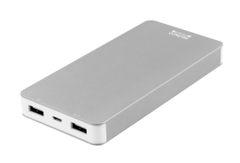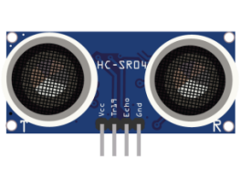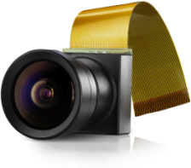

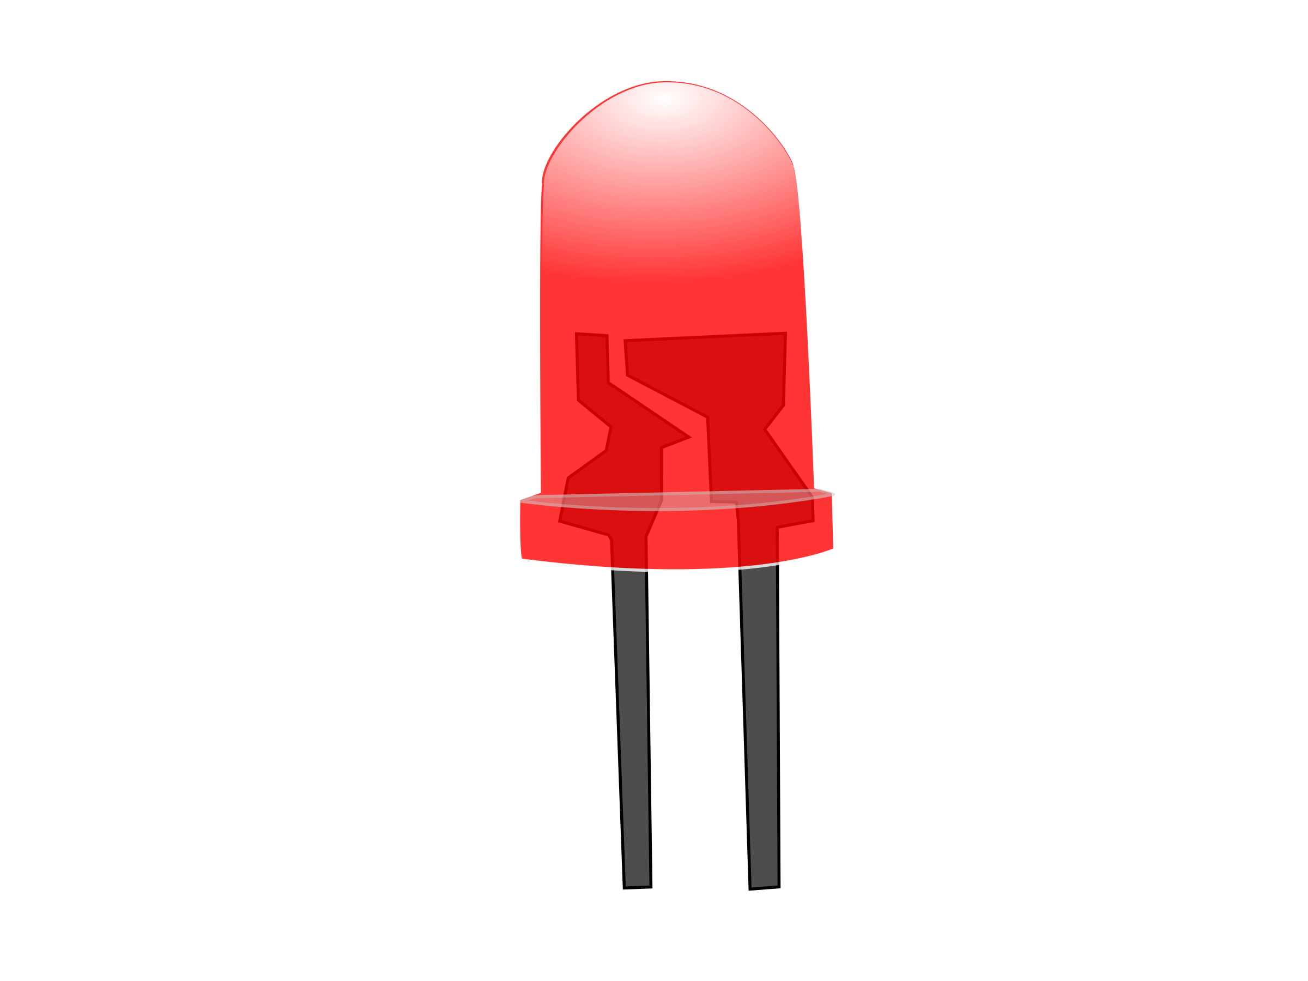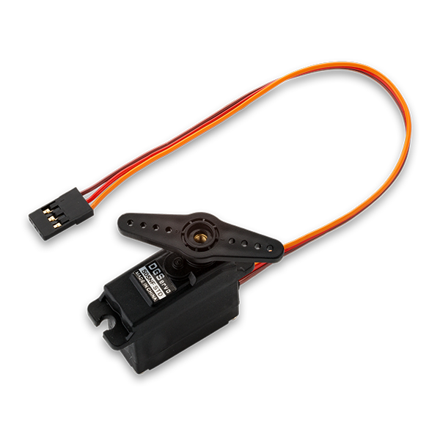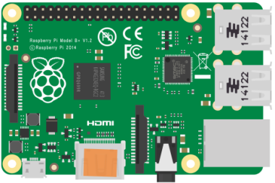

LED Indicator

Speaker

Servo motor 1

Servo motor 3

Servo motor 2

Microcontroller

Camera module

Ultrasonic sensor

Power bank

* Power Bank: Portable power source to supply to all hardware components
* Microcontroller: Core processing unit for input/output control and integration logic
* Camera Module: Captures images of incoming waste for classification
* Servo Motor 1: Rotates platform to align the correct compartment beneath the drop point
* Servo Motor 2: Controls the lid opening/closing and drop release mechanism
* Servo Motor 3: Activates coin dispenser for reward when recyclable material is detected
* LED Indicator: Provides visual feedback (e.g., bin full, item accepted, error state)
* Speaker/Buzzer: Emits sound for alerts (e.g., successful drop, bin full, invalid item)

### 4.4.2. Detailed Design

### 4.4.3. Physical Design

## 4.5. Conclusion